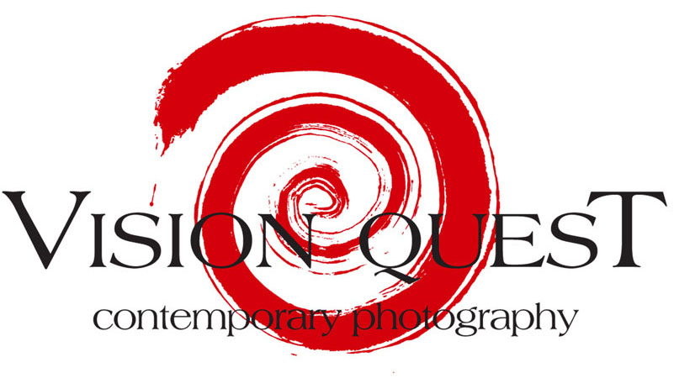

PRESS RELEASE

Collective photographic exhibition

COLLETTIVO 180

Vasco ASCOLINI, Gianni BERENGO GARDIN, Giorgio BERGAMI, Bruno CATTINI,
Enzo CEI, Carla CERATI, Mario DONDERO, Michele D’OTTAVIO, Claudio ERNE, Uliano LUCAS, Christian MARTINELLI, Giordano MORGANTI, Giacomo SAVIOZZI,
Giovanni SESIA, Massimo Stefanetti, Filippo URBINI

Curator: Fabrizio Boggiano
Opening: VISION QUEST: Thursday 9th October 2008, 6pm to midnight
Ex o.p. di Quarto: Friday 10th October 2008, 6.30 p.m. to 10.30 p.m.
Period: 9th October to 30th November 2008-09-18
Centres: VISION QUEST, Piazza Invrea 4 r, 16123 Genova
Ex o.p. di Quarto, Via G. Maggio, 6, Genova
Tel.: +39 339 7534993
+39 010 265629
Opening times: VISION QUEST: Wednesday, Thursday, Friday 3.30pm to 7.30 p.m.
Saturday 10.00 am to 12.30/15.30 to 19.30 p.m. or by appointment
Ex o.p. di Quarto: Monday to Sunday 8 a.m. to 5 p.m.
Website: www.visionquest.it
Email information info@visionquest.it
Catalogue : available in gallery, bilingual (Italian/English), with texts by
Fabrizio Boggiano and Prof. Antonio Slavich, VISION QUEST
Editions, Genoa.

The artists shall be present at the openings

VISION QUEST Contemporary Photography is happy to open the 2008- 2009 artistic season by
presenting the collective photographic exhibition entitled COLLECTIVE 180.

Thirty years after the approval of law 180 which was also known as the “ Basaglia Law” taken
from the name of the psychiatrist who promoted this law, we felt the need to put together an
exhibition. We didn’t want to create a celebratory exhibition, but rather one which would be able to
once again attract attention to a particularly important theme, that of mental health.
The 70’s constituted the most active period of our Italian Republic; there were debates on the
subjects of terrorism, the mafia, political misdemeanors, not to mention new social ideals and deep
reaching civil battles. All of these phenomena led to important State laws.
Today, we’d prefer to forget all of this but an even more serious tendency is that of once again
arguing out these matters and reorganizing those self same laws. In this way important
achievements have been nullified. Therefore, in the spirit of the facts above we intend to carry
forward a small but important contribution aimed at re-awakening the memory and at increasing
the awareness of how this attention must be constant and acute.
Consequently, the exhibition shall commence with historical pictures from the years 1967 to 1970 when it was possible, thanks to Franco Basaglia and his co-workers, for some individuals to gain entry into psychiatric hospitals and to photograph the horrors within their 4 walls. Attention towards a world which up until those years had been intentionally hidden away grew inexorably thanks to these pictures, and many photographers started and continued to document every aspect of it.
Since that time thirty years of the law have passed, and forty years have passed since the opening of the first psychiatric wards: many things have been achieved but there are still more yet to be achieved.
The exhibited photographs span this complete arc of time fixing one’s attention by, before everything else, obliging one to reflect on today’s situation. This state of affairs today is running the risk of tragically slipping backwards and falling into the hands of indifference and shameful speculation.
For these reasons therefore part of the exhibition shall be held inside the ex- Psychiatric Hospital of Quarto, Genoa, together with projections, meetings and other events. One of these shall be a true and proper showing of the “Fourth Eye!” exhibition: young photographers together with the staff of the institute and some of the patients shall make their own contribution. They’ll be given a disposable camera (same model for everyone) with which they’ll be able to freely photograph the goings on inside the hospital. A selection of their work shall then be exhibited inside the ex- Psychiatric Hospital and published in the exhibition catalogue.
All of this shall be to demonstrate the very importance of demolishing every type of barrier; at the same time it shall also serve as a protest against those individuals who would like to hide away suffers of mental illness from the eyes of society.
In fact, it’ll never be possible to fight back against this society which is by now based on appearance only, if we continually allow the bandages to fall over our eyes in a mist of silence.

Fabrizio Boggiano

VISION QUEST Contemporary Photography
Piazza Invrea 4r, 16123 Genova
Tel. 010 265629 - 3397534093 www.visionquest.it info@visionquest.it

This mail newsletter –sent out in CCN- to editorial offices or persons with the aims of transmitting
information regarding cultural events does not contain advertising nor promotions of a commercial nature.
Bearing in mind that undesirable emails are a disturbance, we kindly beg you to accept our most sincere
apologies if this communiqué is not to your liking. In accordance with law 675/96 we have located your
email address via the internet or from emails which included the same. This message does not fall under the
definition of SPAM taken that it can be removed from other email transmissions.
If you do not desire to receive further communications we kindly ask you to send a reply to:
info@visionquest.it with the object ELIMINATE. Thank you.
If you use other accounts, please specify the exact address to be removed.

